

Threading Training Plan
Version 1.0

Author: Shereef Sakr

Plan Change version

Reviewers
Date | Author | Version | Action | Reviewer | Comments
08/11/2015 | Shereef Sakr | 1.0 | Creation

Document Conventions

Terms and Definitions
Term / Abbreviation | Definition
SQL | Structured Query Language
OOP | Object oriented Programming
JMS | Java Messaging Service

Table of Contents
Plan Change version ii
Reviewers ii
Document Conventions 1
Terms and Definitions 1
1 Training Objective 1
2 Training Prerequisites 1
3 Training Outline 1
4 Training Material 1
5 Training Time Table 2
6 Thread Assignment Objective: 3
6.1 System Overview: 3

Training Objective
This training targets to master threading along with an introduction to Oracle Advanced Queues.

Training Prerequisites
- Knowledge of the Java language
- Basic understanding on database connectivity using JDBC

Training Outline
The training covers the following areas:
- Threading
- Oracle Advanced Queues

Training Material

Topic | Material
Threading | - Java Threads book

Training Time Table

 | Topics | Material
1 Day | Threading session | Presentation
 | Threading Assignment
2 Days | Implement a basic threading application

Thread Assignment Objective:
To create a high performance engine that can handle a large number of requests with good efficiency and certain rate. Also the engine should maintain its availability 24/7

System Overview:
Our engine will read CSV files on different folders. Read each line in all files. Each line will contain an SMS that needs to be sent to a customer. The SMS needs to be queued in a database queue (Oracle Advanced Queue). After each SMS in put in queue, archive the SMS data sent into a history table, along with time and date, and enqueue time (the time it takes to enqueue in database).
The requests will be just a mobile number and a message text (comma separated)



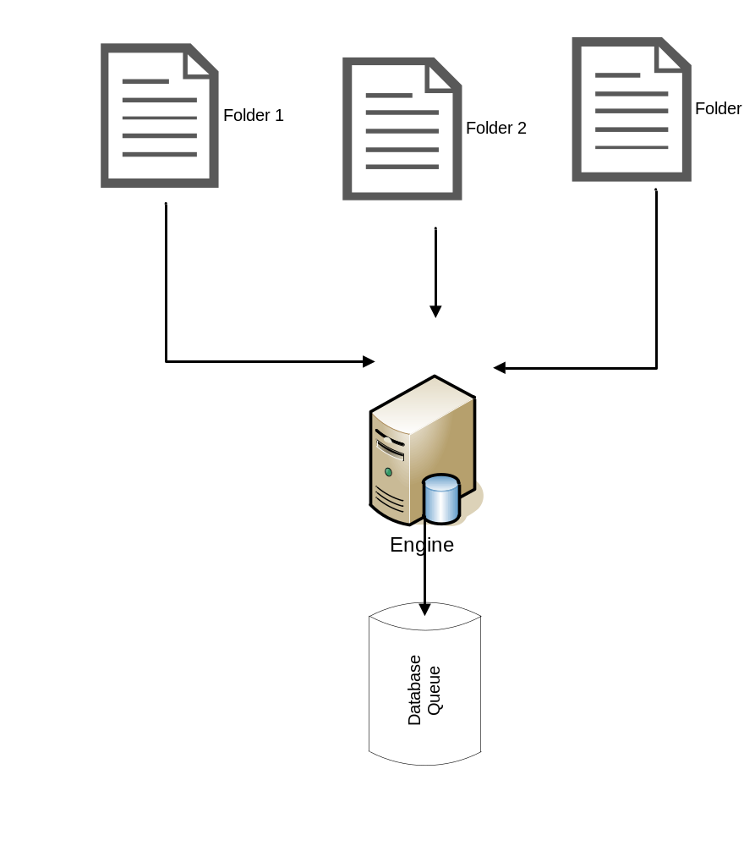

Functional Requirements

- Engine will be running 24/7.
- Shutdown engine using flag in database.
- Handle case if a problem occurred when enqueuing in database.
- Engine must handle up to 1000 request/min.
- All threads should be handled using thread pools.
- All threading related parameters should be configurable.
  - Thread pool number (if using fixed thread pool)

Guidelines

- Use Apache Commons CSV for parsing the file.

